5.1.1 : Leap Year Checker
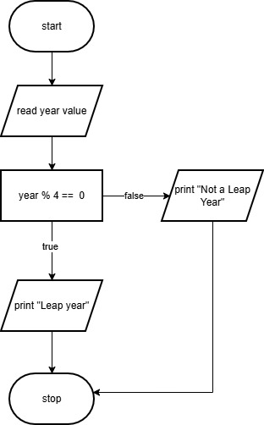
Flow Chart :

Algorithm:
- Start
- Read an integer value year from the user.
- Check if year % 4 == 0
  - If true, print "Leap year"
  - Else, print "Not a leap year"
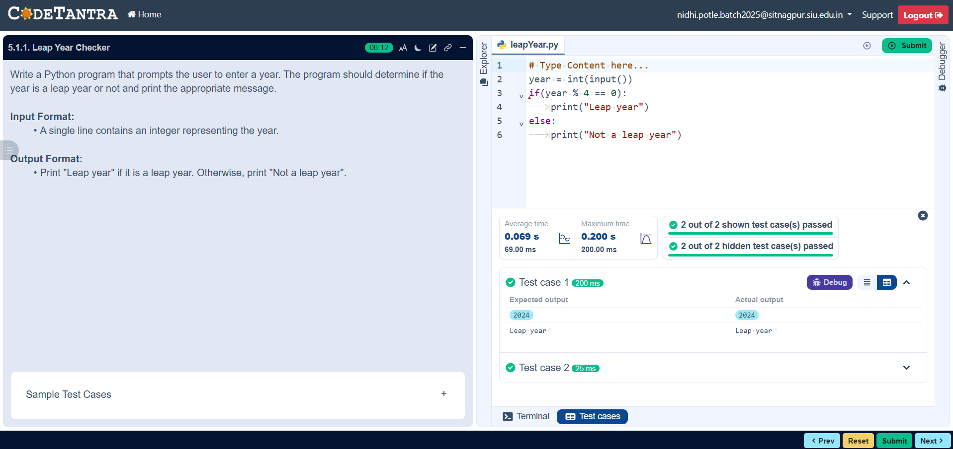
- Stop
5.1.2 : Student Grade Based on Aggregate
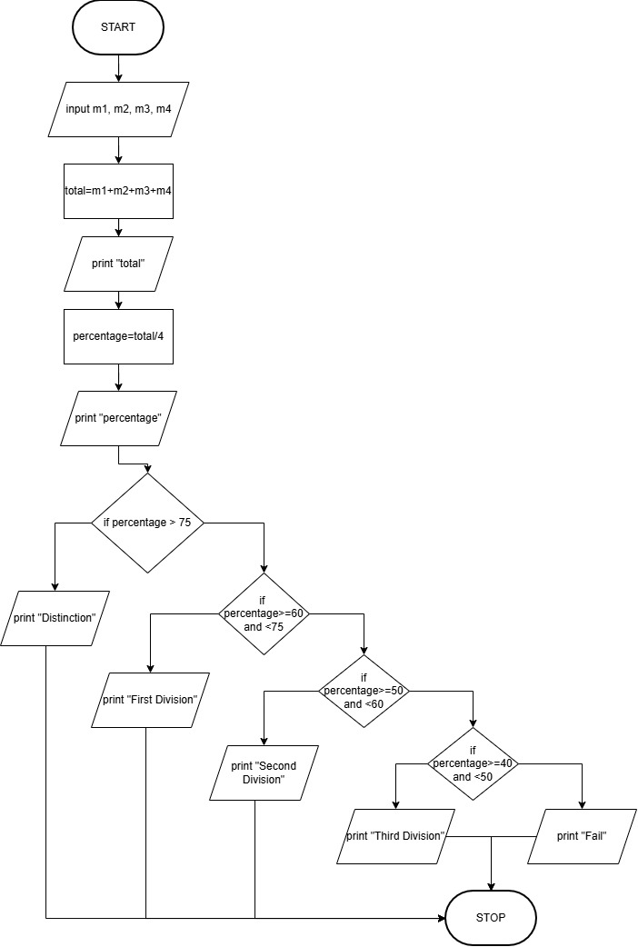
Flow Chart :

Algorithm:
- Start
- Input four integers: a, b, c, d
- Compute total marks
total = a + b + c + d
- Print total
- Compute percentage
percentage = (total / 400) × 100
- Print percentage (formatted to 2 decimal places)
- If percentage > 75
→ Print "Distinction"
- Else if percentage >= 60 and < 75
→ Print "First Division"
- Else if percentage >= 50 and < 60
→ Print "Second Division"
- Else if percentage >= 40 and < 50
→ Print "Third Division"
- Else
→ Print "Fail"
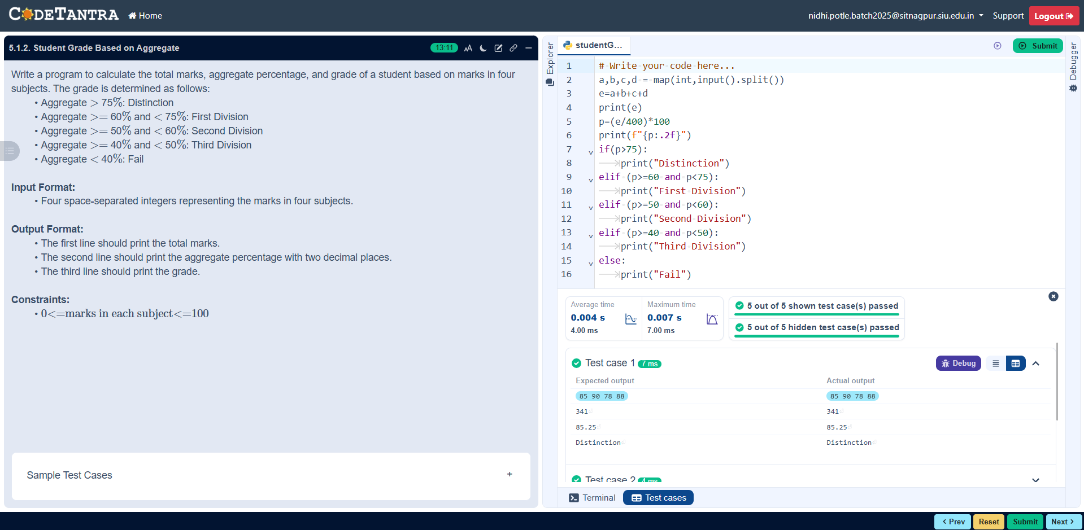
- Stop

